**Day_09 Assignment**

**Port forwarding:**

Created an application that consists of deployment and a service named simpleservice on port 80



Traffic is forwarded to our local system using port-forward



Verifying the service is accessible by accessing it over port 8080(using a separate terminal)



Disconnecting the port



After deleting a pod

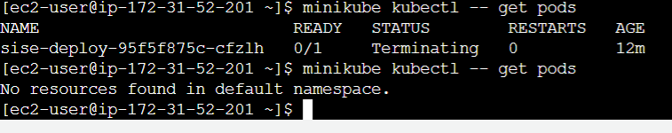

**Volumes:**

Created a pod with two containers using an emptyDir volume to exchange data



Getting the volume information

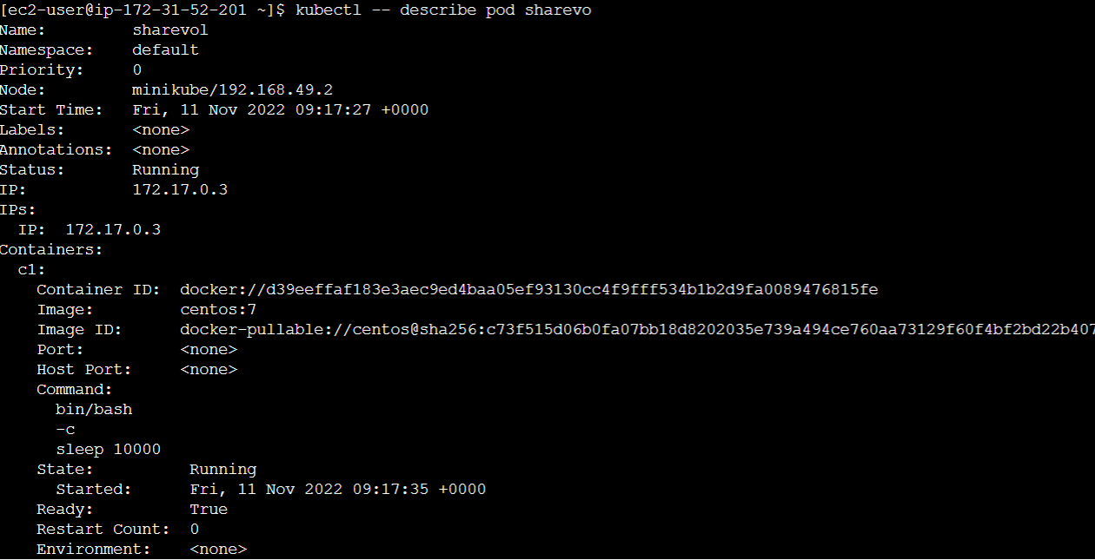

Connecting to one of the containers in the pod, c1 to view the volume mount and generate some data and volume is mounted



Creating a file in the mount and able to access from other container in the pod

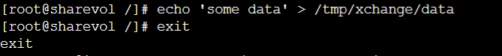

Connecting to the container c2, the second container running in the pod, see the volume mounted at /tmp/data and are able to read the data created



Deleting the pod

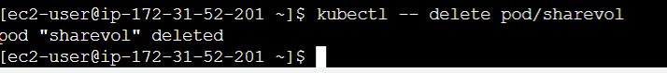

**Services:**

Creating a pod supervised by a replication controller and service



Checking the pod is running or not



Information of pod

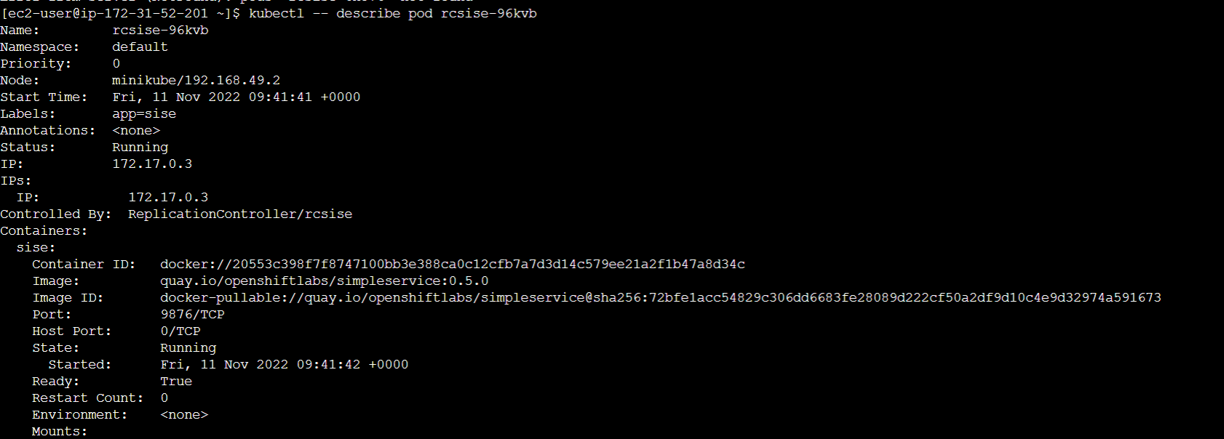

Accessing the pod directly via assigned ip 172.17.0.3:9876



Getting the service information



Adding a second pod by scaling up the rc supervising it



Two pods are running

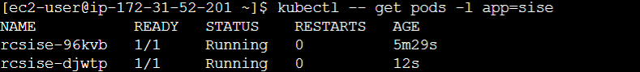

Deleting all the resources



**Secert:**

Creating a secret named apikey



Created the secret



Information about the secret

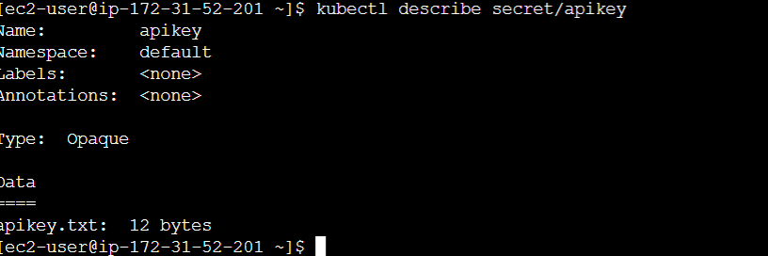

Using the secret in a pod through volume



Connect to the container to verify the attached secret and secret is mounted at /tmp/apikey

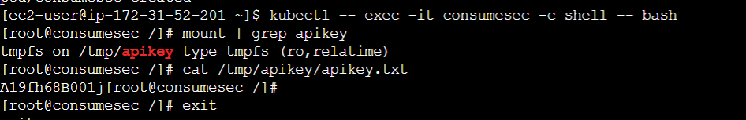

Deleting both the pod and secret

